Name : Dhavalkumar Vijaykumar Patel
Subject : Essential of Cyber Security and Cyber Waefare
Class : M.Sc Cyber Security
Semester : 1

Lab 5 :

- pwdump3 utility to obtain password hashes
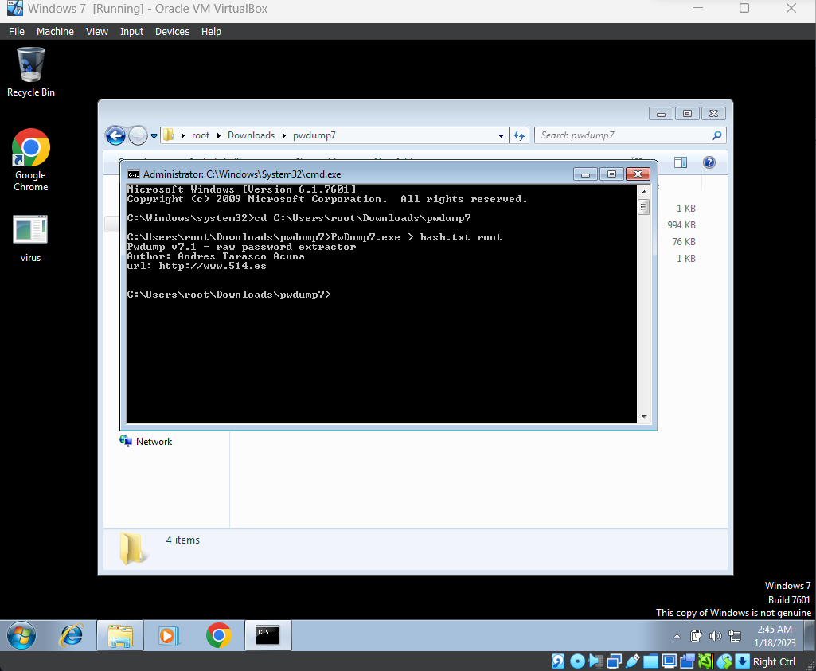
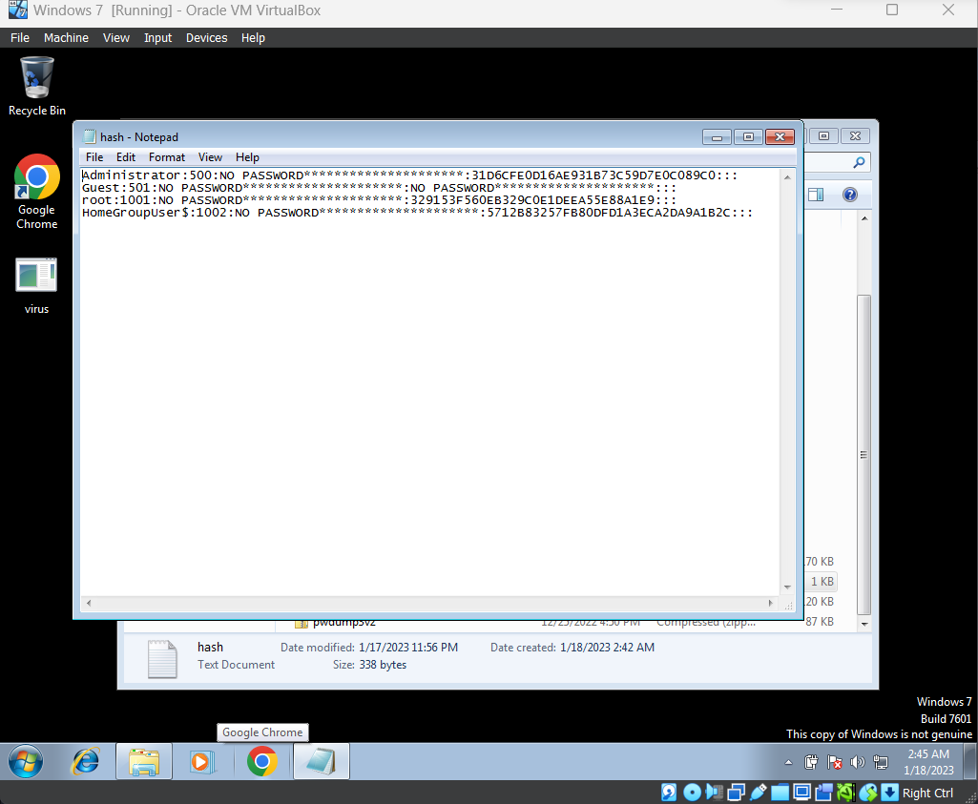
- John the Ripper password cracking utility

john.exe --format=nt --show hash.txt
Use this command to crack the password hash of the file
